BANKING MANAGEMENT SYSTEM
Technical Report
Visvesvaraya Technological University
Jnana Sangama, Belagavi, Karnataka
AMC Engineering College
AMC Campus, Bannerghatta Main Road, Bengaluru, Karnataka 560083
Developed By | Akshith Peri
USN | 1AM24CS013
Guided By | Prof. T K Pradeep Kumar

1. Abstract
The Banking Management System (BMS) is a full-stack web application designed to digitize and streamline the management of banking operations. The system enables users to manage records of employees, customers, bank accounts, transactions, payments, loans, fixed deposits, recurring deposits, beneficiaries, and audit logs through a centralized platform. It follows a three-tier architecture consisting of a frontend web interface, an Express.js backend REST API, and a MySQL relational database. The project demonstrates practical implementation of REST API design, relational database modeling, JWT-based authentication, role-based access control, and dynamic frontend rendering.

2. Introduction
Banking Management Systems are software solutions that automate administrative and transactional tasks in financial institutions. Traditional manual methods of maintaining banking records using paper registers and spreadsheets are prone to errors, data redundancy, and retrieval delays. This project addresses the need for a simple, secure, web-based solution to manage banking data efficiently.

The objectives of this project are:
- To provide a centralized interface for managing employees, customers, accounts, transactions, and loans
- To implement role-based access control for Admin/Employee and Customer portals
- To support automated EMI schedule generation and loan approval workflows
- To offer real-time account balance tracking, transaction history, and audit logging
- To support Fixed Deposits, Recurring Deposits, Beneficiary management, and KYC verification

3. Technologies Used

Layer | Technology | Purpose
Frontend | HTML5, CSS3, JavaScript (ES6) | User interface and interactivity
Frontend Libs | Font Awesome 6.4, Chart.js, Google Fonts | Icons, charting, typography
Backend | Node.js, Express.js 4.18 | REST API server
Auth | bcryptjs, jsonwebtoken (JWT) | Password hashing and token-based auth
Database | MySQL (via mysql2 driver) | Data storage and relational modeling
Middleware | cors, dotenv | Cross-origin access, environment config
Tools | VS Code, npm, Thunder Client | Development and API testing

4. System Architecture
The system follows a three-tier architecture. The Frontend (Browser) communicates with the Backend (Express.js on port 5000) via HTTP requests carrying JSON payloads and JWT tokens. The Backend processes requests through route handlers and controllers, then interacts with a MySQL database using a connection pool. Authentication is enforced at the middleware layer using JWT verification before protected routes are accessed.

Architecture Diagram
FRONTEND [Browser] | BACKEND [Express.js] | DATABASE [MySQL]
HTML5 · CSS3 · JS Chart.js · Font Awesome Port: N/A | Node.js REST API Server JWT Auth Middleware Port: 5000 | NexaBank DB MySQL Connection Pool 13 Tables

Data Flow Example:
- User logs in via the Customer/Admin portal in the browser
- app.js sends POST to http://localhost:5000/api/auth/login with credentials
- Express verifies credentials via bcryptjs and returns a signed JWT
- Subsequent requests include the JWT; middleware validates it before each route
- Controllers execute parameterized SQL queries against MySQL
- MySQL returns data rows; Express responds with JSON rendered dynamically in browser

5. Database Design
The database ( NexaBank) contains thirteen tables linked through foreign keys, supporting a comprehensive banking domain model. The schema enforces referential integrity through cascading deletes and null-on-delete policies appropriate to each relationship.
Entity-Relationship (ER) Diagram
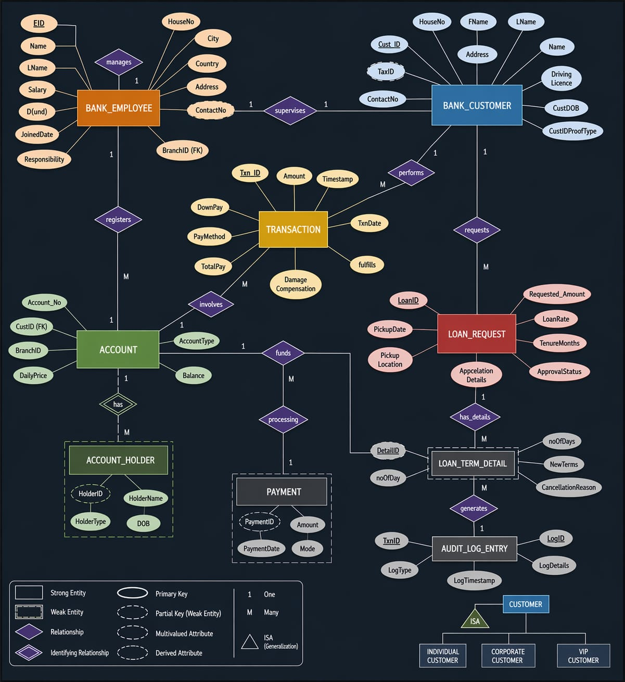
Figure: ER Diagram of the Banking Management System

Table | Primary Key / Key Columns | Foreign Key
BANK_EMPLOYEE | EID (PK), Name, LName, Email, Salary, Responsibility, BranchID | —
BANK_CUSTOMER | Cust_ID (PK), FName, LName, TaxID, KYCStatus, CustomerType, Email | —
ACCOUNT | Account_No (PK), AccountType, Balance, CreatedAt | CustID → BANK_CUSTOMER
ACCOUNT_HOLDER | HolderID (PK), HolderName, HolderType, Relationship | Account_No → ACCOUNT, Cust_ID → BANK_CUSTOMER
TRANSACTION | Txn_ID (PK), Amount, Transaction_Type, Description, PayMethod | CustID → BANK_CUSTOMER, Account_No → ACCOUNT
PAYMENT | PaymentID (PK), Amount, PaymentDate, Mode | Txn_ID → TRANSACTION
LOAN_REQUEST | LoanID (PK), Requested_Amount, LoanRate, TenureMonths, ApprovalStatus | Cust_ID → BANK_CUSTOMER
LOAN_TERM_DETAIL | DetailID (PK), noOfDays, NewTerms, CancellationReason | LoanID → LOAN_REQUEST
LOAN_EMI_SCHEDULE | EMI_ID (PK), DueDate, EMIAmount, PrincipalComponent, Status | LoanID → LOAN_REQUEST
FIXED_DEPOSIT | FD_ID (PK), Principal, InterestRate, TenureMonths, MaturityAmount | Cust_ID → BANK_CUSTOMER
RECURRING_DEPOSIT | RD_ID (PK), MonthlyInstallment, InterestRate, TenureMonths, MaturityAmount | Cust_ID → BANK_CUSTOMER
BENEFICIARY | Ben_ID (PK), Ben_Name, Ben_Account_No | Cust_ID → BANK_CUSTOMER
AUDIT_LOG_ENTRY | LogID (PK), LogType, LogTimestamp, LogDetails | TxnID → TRANSACTION, DetailID → LOAN_TERM_DETAIL
EMPLOYEE_SUPERVISES_CUSTOMER | EID + Cust_ID (Composite PK) | EID → BANK_EMPLOYEE, Cust_ID → BANK_CUSTOMER

Key Relationships
- BANK_CUSTOMER (1) --- ACCOUNT (Many)
- ACCOUNT (1) --- TRANSACTION (Many)
- BANK_CUSTOMER (1) --- LOAN_REQUEST (Many)
- LOAN_REQUEST (1) --- LOAN_EMI_SCHEDULE (Many)
- BANK_CUSTOMER (1) --- FIXED_DEPOSIT (Many)
- BANK_CUSTOMER (1) --- RECURRING_DEPOSIT (Many)
- BANK_EMPLOYEE (Many) --- BANK_CUSTOMER (Many) via EMPLOYEE_SUPERVISES_CUSTOMER

6. Modules and Features

6.1 Authentication Module
A login page with role-based access for Admin/Employee and Customer portals. Passwords are hashed using bcryptjs. Authentication uses JWT tokens issued on successful login and validated by middleware on every protected API route. Session tokens are stored in the browser's localStorage.

6.2 Dashboard Module
Displays summary statistics including total customers, accounts, transactions, active loans, and total balance. Uses Chart.js to render bar charts and line graphs for transaction trends and deposit summaries. All summary data is fetched in parallel using Promise.all for optimal performance.

6.3 Customer Management Module
Allows Admin to view, add, and manage bank customers. Includes KYC status tracking (PENDING / VERIFIED / REJECTED) and customer type classification (INDIVIDUAL, CORPORATE, VIP). Each customer can have multiple accounts, loans, FDs, and RDs.

6.4 Account & Transaction Module
Manages bank accounts with support for SAVINGS, CURRENT, and other account types. Tracks real-time balance. Transactions are logged as CREDIT or DEBIT with payment method details. Supports beneficiary-based fund transfers.

6.5 Loan Management Module
Customers can apply for loans with specified amount, interest rate, and tenure. Admin can APPROVE or REJECT loan requests. On approval, an EMI schedule is auto-generated using standard reducing balance calculations. Loan term details and cancellations are tracked separately.

6.6 Fixed Deposit & Recurring Deposit Module
Customers can open Fixed Deposits (lump sum) and Recurring Deposits (monthly installments). The system calculates and stores maturity dates and maturity amounts at the time of creation. Status is tracked as ACTIVE, MATURED, or CLOSED.

6.7 Role-Based Access Control
Admin/Employee role can manage employees, approve loans, verify KYC, and monitor all accounts. Customer role can view their own accounts, transactions, apply for loans, add beneficiaries, and manage FD/RD. Access is enforced server-side via JWT claims and middleware.

6.8 Audit Log Module
All significant system events (transactions, loan changes) are recorded in the AUDIT_LOG_ENTRY table with timestamps, log type, and details. This provides a traceable history of operations for compliance and debugging.

7. API Endpoints
Method | Endpoint | Description
POST | /api/auth/login | User login (Employee or Customer)
GET | /api/employees | List all bank employees
POST | /api/employees | Add a new bank employee
GET | /api/customers | List all customers (with KYC status)
POST | /api/customers | Register a new customer
GET | /api/accounts | List all accounts (with balance)
POST | /api/accounts | Open a new bank account
GET | /api/transactions | List all transactions
POST | /api/transactions | Post a new transaction (credit/debit)
GET | /api/loans | List all loan requests
POST | /api/loans | Submit a new loan application
PUT | /api/loans/:id/approve | Approve a loan request
PUT | /api/loans/:id/reject | Reject a loan request
GET | /api/fixed-deposits | List all fixed deposits
POST | /api/fixed-deposits | Open a new fixed deposit
GET | /api/recurring-deposits | List all recurring deposits
POST | /api/recurring-deposits | Open a new recurring deposit
GET | /api/beneficiaries | List beneficiaries for a customer
POST | /api/beneficiaries | Add a new beneficiary
GET | /api/payments | List all payments
GET | /api/audit | Fetch audit log entries
GET | /api/credit-cards | Credit card management
GET | /api/investments | Investment management

8. Implementation Highlights
- Server (Backend/server.js): Express app with 13 API route modules, JWT auth middleware, MySQL connection pool with auto-init, CORS, and environment-based configuration via dotenv.
- Database Init (Backend/config/db.js): Automatically creates the database and all tables on first run using a comprehensive schema (10,134-line DDL), ensuring zero-configuration setup for new developers.
- Frontend Logic (Frontend/app.js): 186,692-byte single-file frontend handling page routing, fetch-based API calls, dynamic table rendering, modal forms, Chart.js dashboards, toast notifications, and role-based UI injection.
- Styling (Frontend/styles.css): 63,087-byte stylesheet implementing a modern fintech-grade design with responsive layout, glassmorphism effects, gradient backgrounds, and custom scrollbars. Supplemented by mobile.css for responsive breakpoints.
- Security: All database queries use parameterized placeholders to prevent SQL injection. Passwords are hashed with bcryptjs (salt rounds = 10). JWT tokens are verified on every protected route via auth middleware.
- Loan EMI Generator (Backend/controllers/loanCalculator.js): Implements reducing-balance EMI computation and generates a full month-by-month repayment schedule stored in LOAN_EMI_SCHEDULE on loan approval.

9. Outputs
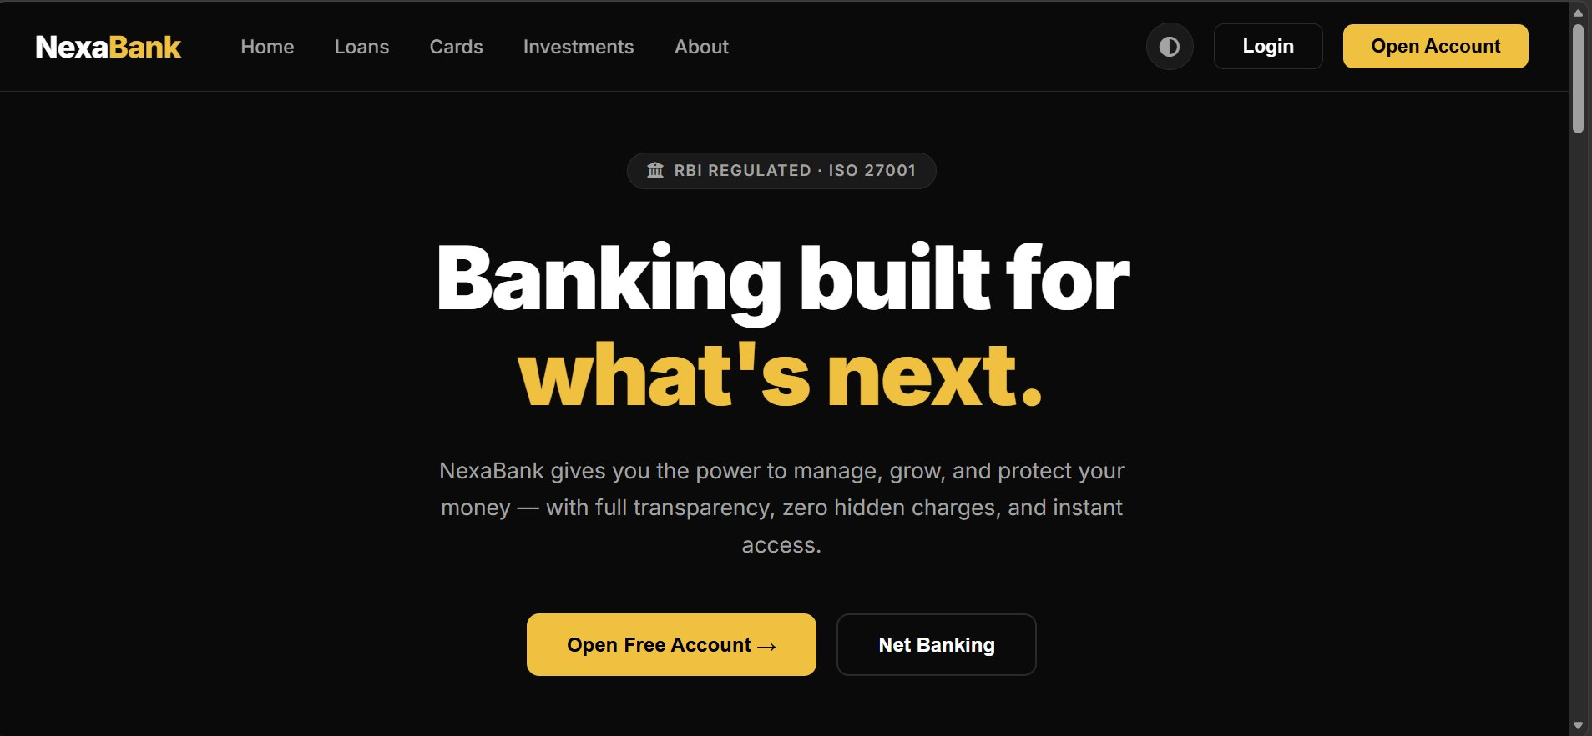
Figure 9.1: NexaBank Home Page — Banking built for what's next
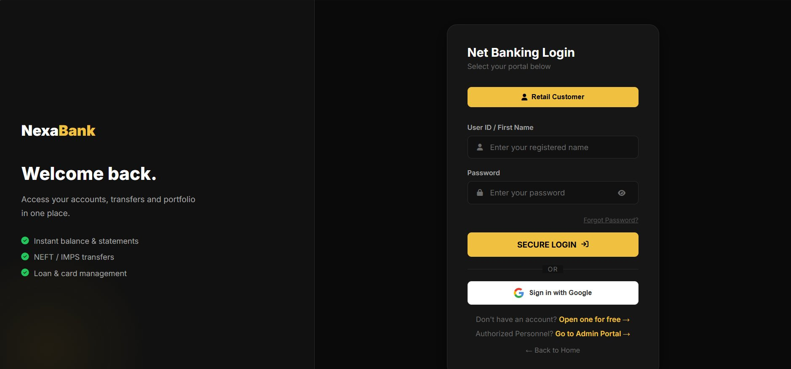
Figure 9.2: Net Banking Login — Customer Portal
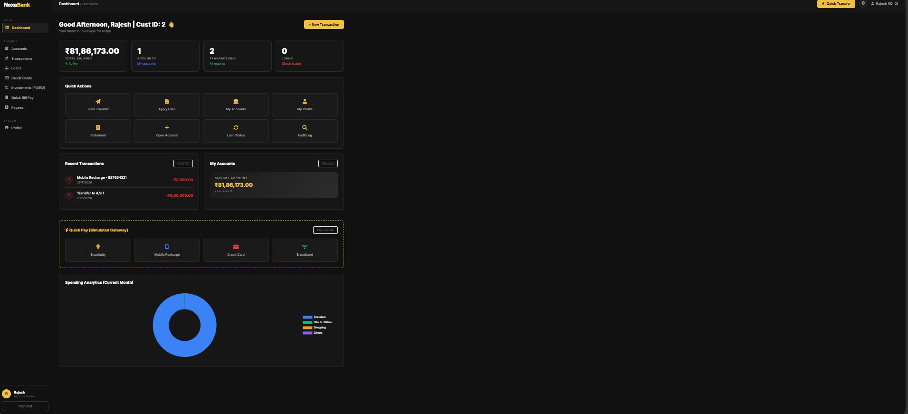
Figure 9.3: Customer Dashboard — Account Overview and Quick Actions
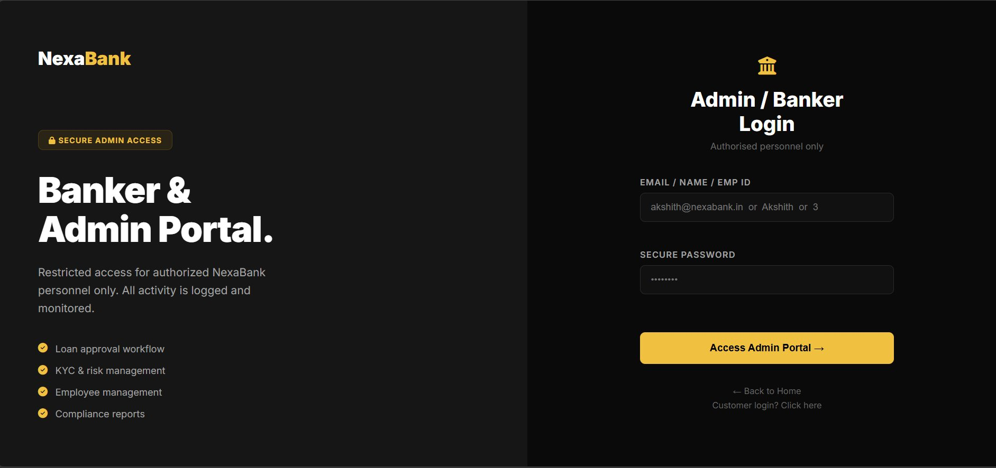
Figure 9.4: Admin / Banker Login Portal
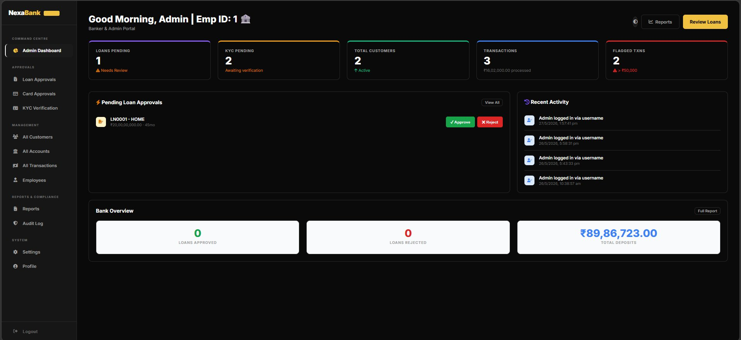
Figure 9.5: Admin Dashboard — Loan Approvals, KYC, and Bank Overview

10. Advantages
- Comprehensive banking domain coverage: accounts, loans, FD/RD, payments, audit, KYC
- Secure JWT-based authentication with bcrypt password hashing
- Automated EMI schedule generation on loan approval
- Real-time balance tracking and transaction history
- Role-based access control enforced both client-side and server-side
- SQL injection protection via fully parameterized queries
- Auto-initializing database schema requiring no manual setup
- Responsive, modern fintech-grade UI with Chart.js data visualizations

11. Future Enhancements
- Implement OTP-based two-factor authentication for customer login
- Add full CRUD support (PUT/DELETE) for all entity management pages
- Implement pagination and server-side search for large datasets
- Integrate a real payment gateway (Razorpay or Stripe) for live transactions
- Add appointment scheduling for branch visits and loan counseling
- Containerize the application with Docker for portable deployment
- Add unit and integration tests using Jest and Supertest
- Deploy on cloud infrastructure (AWS RDS + EC2 or Railway) with HTTPS

12. Conclusion
The Banking Management System successfully demonstrates a complete three-tier web application for managing financial institution data. The project applies core software engineering concepts including RESTful API design, relational database modeling, JWT-based authentication, connection pooling, role-based access control, and dynamic frontend rendering. With thirteen interrelated database tables and thirteen API route modules, the system covers a realistic banking domain end-to-end. The system is functional, secure, and serves as a solid foundation for a production-grade banking platform.

13. References
- Express.js Documentation — https://expressjs.com/
- MySQL 8.0 Reference Manual — https://dev.mysql.com/doc/refman/8.0/en/
- mysql2 npm Package — https://www.npmjs.com/package/mysql2
- jsonwebtoken npm Package — https://www.npmjs.com/package/jsonwebtoken
- bcryptjs npm Package — https://www.npmjs.com/package/bcryptjs
- Chart.js Documentation — https://www.chartjs.org/docs/
- MDN Web Docs: Fetch API — https://developer.mozilla.org/en-US/docs/Web/API/Fetch_API
- MDN Web Docs: localStorage — https://developer.mozilla.org/en-US/docs/Web/API/Window/localStorage
- Font Awesome Icons — https://fontawesome.com/
- Google Fonts — https://fonts.google.com/

